1. What is the importance of functions in Python?
Functions in Python help in organizing code into reusable blocks. They increase modularity, reduce redundancy, and improve code readability. Functions allow developers to break down complex tasks into smaller, manageable parts. Additionally, they make code maintenance easier and facilitate code reuse.

2. Explain the difference between default arguments and keyword arguments in Python.

[Machine Learning Engineer], [Infosys, Microsoft], 3

✅ Default Arguments:
- Arguments that have a default value if not provided by the user.
- Defined during function declaration.
- Used when most cases have the same value.

✅ Keyword Arguments:
- Arguments passed by parameter names, not positions.
- Makes the code more readable and order-independent.
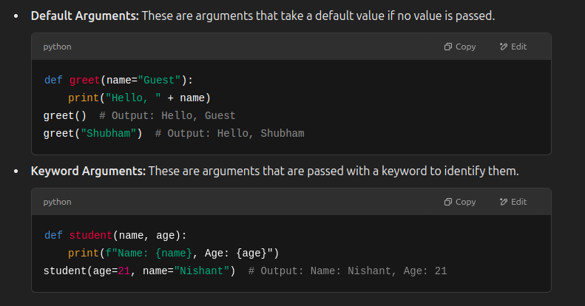
3. What are *args and kwargs in Python, and how are they used?
[Data Science, Data Analytics], [Swiggy, Google], 2

*What is args?
- Stands for "arguments" and allows you to pass a variable number of arguments to a function.
- Treated as a tuple inside the function.

**What is kwargs?
- Stands for "keyword arguments" and allows passing key-value pairs.
- Treated as a dictionary inside the function.

💡 When to Use:
- Use *args when you are unsure about the number of arguments.
- Use **kwargs when you want to pass a dictionary of key-value pairs.

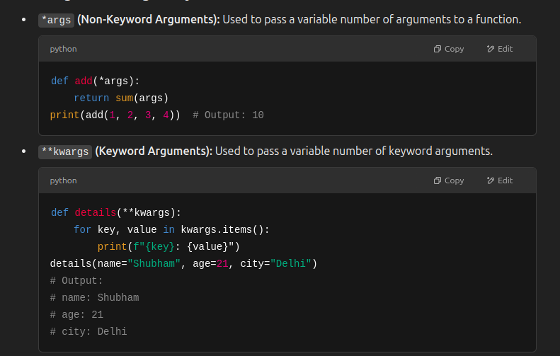
4. How do iterators differ from generators? Provide examples.

✅ Iterators:
- An object that contains a countable number of values.
- Uses the iter() and next() functions.
- Iterators do not store data in memory, they generate data on the fly.

✅ Generators:
- Functions that yield values one at a time.
- They don’t store values in memory, making them more memory-efficient.

🚩 Difference:
- Syntax: Generators use yield, iterators use __iter__() and __next__().
- Memory Efficiency: Generators are more memory-efficient.
- Usage: Generators are used when the entire sequence doesn’t need to be stored in memory.
5. Explain lambda functions in Python. How are they different from normal functions?
[Data Science, Data Analytics], [Amazon, Tata Consultancy], 3
Lambda functions are anonymous functions (without a name) defined using the lambda keyword.
- Syntax: lambda arguments: expression
- Generally used for short, single-line functions.
Difference from Normal Functions: Lambda functions are limited to a single expression and do not have a name, whereas normal functions can have multiple expressions and a name.
6. How would you use map(), filter(), and reduce() in Python? Provide examples.
[Machine Learning Engineer, Data Science], [Google, Flipkart], 2
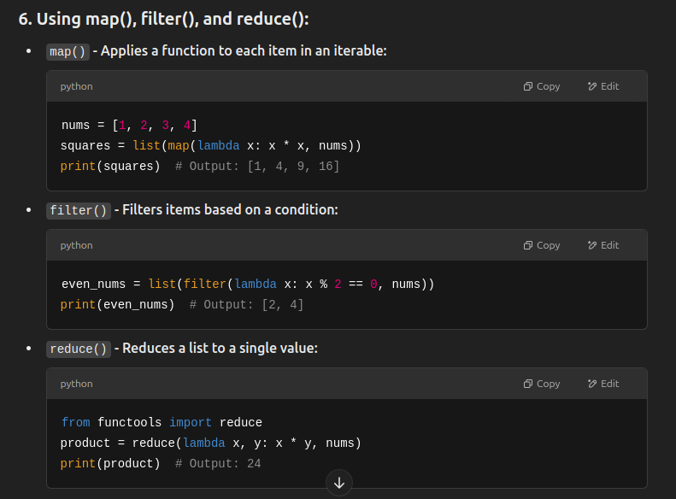
7. What is the benefit of using lambda expressions with map and filter functions?
[Data Analytics, Machine Learning Engineer], [TCS, IBM], 2
Lambda expressions are concise and efficient when used with functions like map() and filter(). Lambda functions make map and filter super compact and easy to use without defining a separate function.

8. What are classes and objects in Python? Explain with examples.
A class is a blueprint or template for creating objects. It defines a set of attributes (data) and methods (functions) that are common to all objects of that class.
- Classes are defined using the class keyword.
- The __init__() method is a constructor that initializes the object's state.

✅ Syntax:
class ClassName:
def __init__(self, attribute1, attribute2):
self.attribute1 = attribute1
self.attribute2 = attribute2

def method1(self):
print("This is a method inside the class")

🧩 What is an Object?
An object is an instance of a class. It contains data (attributes) and methods defined in the class.
- We can create multiple objects from a single class.
- Objects are created using the class name followed by parentheses.

✅ Syntax:
object_name = ClassName(value1, value2)

9. Explain the concept of inheritance in Python. How does it work?
[Machine Learning Engineer, Data Science], [Infosys, Cognizant], 3
Inheritance is one of the key concepts of Object-Oriented Programming (OOP) in Python. It allows a class (child class) to inherit properties and methods from another class (parent class).
This helps in reusing the code and building a hierarchy between classes.
10. What is the difference between single inheritance and multiple inheritance in Python?
[Data Science, Business Analyst], [Capgemini, Flipkart], 2
- Single Inheritance: A class inherits from one base class.
- Multiple Inheritance: A class inherits from multiple base classes.

📝 Which One to Use?
- Use Single Inheritance when your class needs to inherit from just one base class.
- Use Multiple Inheritance when your class needs functionalities from multiple classes, but be cautious of method name conflicts.
11. What is encapsulation, and how is it implemented in Python?
[Machine Learning Engineer, Data Science], [IBM, Zomato], 3
Encapsulation is one of the fundamental concepts of Object-Oriented Programming (OOP). It is the process of hiding data (attributes) and methods within a class and restricting direct access to them from outside the class. This helps to protect the data and maintain the integrity of the object.

💡 Why Use Encapsulation?
- Data Protection: Prevents accidental modification.
- Data Hiding: Keeps internal representation hidden.
- Controlled Access: Uses getter and setter methods.
- Code Maintenance: Makes code modular and manageable.

🔑 Private and Protected Attributes
- Private Attributes: Prefixed with __ (e.g., __salary), not accessible from outside the class.
- Protected Attributes: Prefixed with _ (e.g., _age), intended for internal use but accessible.
12. What are static methods and class methods? Explain with an example.

📌 Static Methods:
- Defined using the @staticmethod decorator.
- Do not take the self or cls parameter.
- Cannot access or modify class or instance attributes.
- Used for utility functions related to the class.

📌 Class Methods:
- Defined using the @classmethod decorator.
- Take cls as the first parameter, representing the class itself.
- Can access and modify class-level attributes.
13. What are dunder methods in Python? Why are they useful?
[Data Science, Data Analytics], [Microsoft, Swiggy], 2
Dunder methods (short for double underscore) are special methods in Python that start and end with double underscores like __init__, __str__, __add__, etc.
- These methods enable operator overloading and custom behavior of objects.
14. What is the difference between method overriding and method overloading?
[Machine Learning Engineer, Data Science], [Infosys, Paytm], 3

🚀 Method Overriding:
- Definition: Redefining a method in a subclass that already exists in the parent class.
- Purpose: To change or extend the behavior of the parent method.

✨ Method Overloading:
- Definition: Defining multiple methods with the same name but different parameters.
- Purpose: To perform different tasks with the same method name.

15. Explain the use of decorators in Python and provide an example.
[Data Science, Data Analytics], [Amazon, Wipro], 3
Decorators are a powerful feature in Python that allows you to modify the behavior of a function or class method without changing its actual code.
They are commonly used for logging, authentication, performance measurement, and more.

💡 How Do Decorators Work?
A decorator is a function that takes another function as an argument and returns a modified function.
They are applied using the @decorator_name syntax.

